Traditional architecture

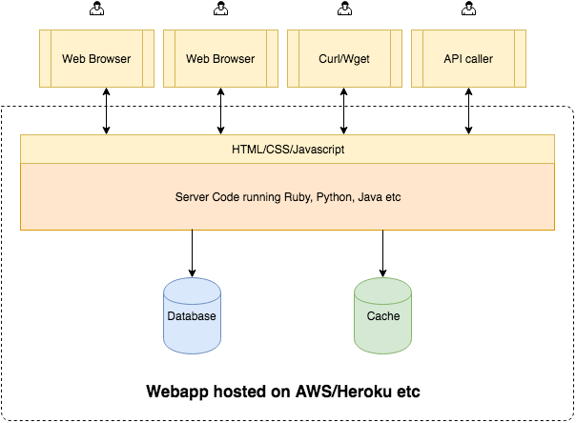

This architecture works very well most of the times. However, there are certain applications where it would be really helpful if that ***database was publicly and securely accessible by everyone*** and you don’t have to rely on this webapp owner for your data.